# Exercise: Networks, Internet and Protocols

Problems for exercises and homework for the ["Software Technologies" course @ Software University.](https://softuni.bg/trainings/4383/software-technologies-january-2024)

## Explore the local network configuration

### 1.1. Find your IP address in the local network

1. Open the command prompt by typing "cmd" in the Windows search bar and clicking on the "Command Prompt" app;

2. Type "**ipconfig**" and press enter;

3. Your IP address will be listed under "IPv4 Address";

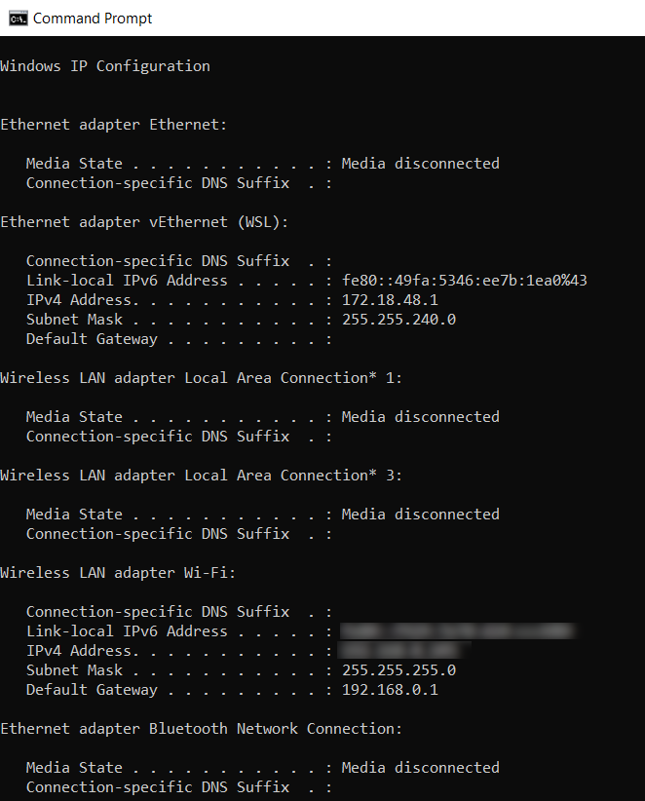

### 1.2. Ping your router

1. In the command prompt, type "ping 192.168.0.1" and press enter.

2. If your router responds, it means you're connected to it.

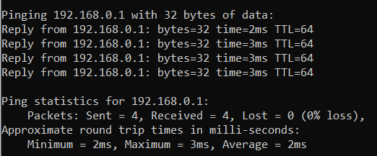

### 1.3. List IP addresses with their MAC addresses

1. In the command prompt, type "arp -a" and press enter.

2. This will show you a list of IP addresses and their corresponding MAC addresses.

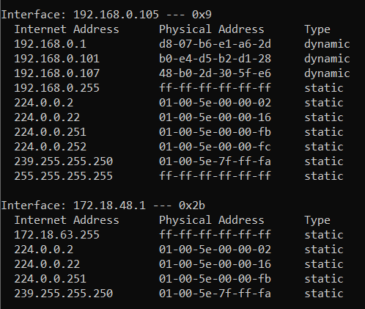

### 1.4. List all open sockets and ports

1. In the command prompt, type "netstat -an" and press enter.

2. This will show you a list of all open sockets and ports on your computer.

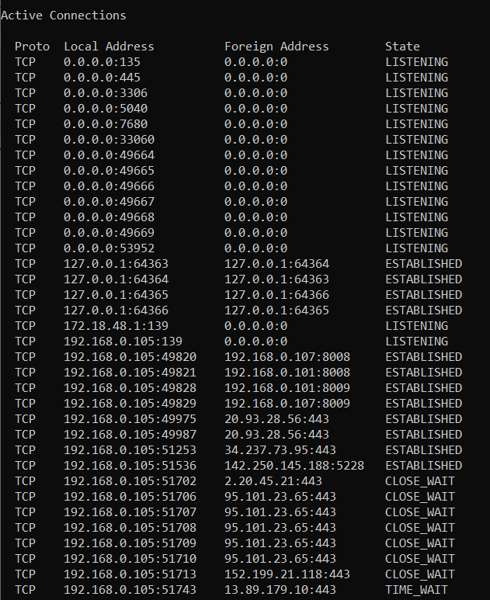

### 1.5. Trace the route to a certain IP address

1. In the command prompt, type "tracert google.com" (replace "google.com" with the IP address or domain name you want to trace) and press enter.

2. This will show you the path that your computer takes to reach that IP address, including any routers or other network devices along the way.

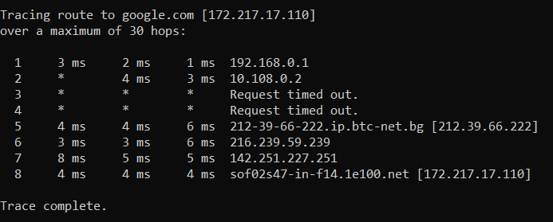

## Lookup domain DNS records online

### 2.1. Find the IP address behind judge.softuni.org

1. Go to the website [**https://mxtoolbox.com/DNSLookup.aspx**](https://mxtoolbox.com/DNSLookup.aspx)

2. Enter **judge.softuni.org** or the domain name you want to look up in the "DNS Lookup" field.

3. Click on the "DNS Lookup" button to perform the lookup.

4. The resulting output will show you the DNS records associated with the hostname, including the IP address if one exists.

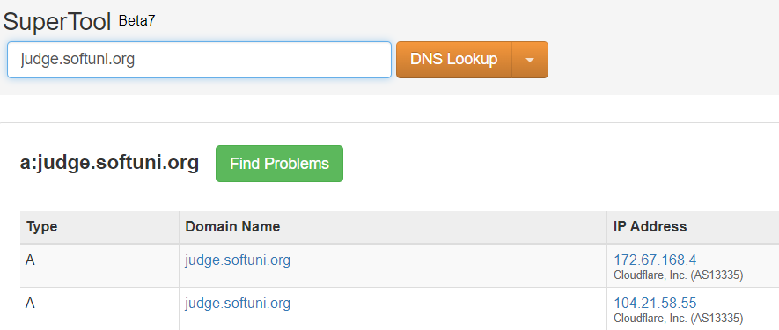

### 2.2. Find the mail server for the domain softuni.org

Go to the website [**https://mxtoolbox.com/MXLookup.aspx**](https://mxtoolbox.com/MXLookup.aspx)

- Enter **softuni.org** in the "MX Lookup" field.

- Click on the " MX Lookup" button to perform the lookup.

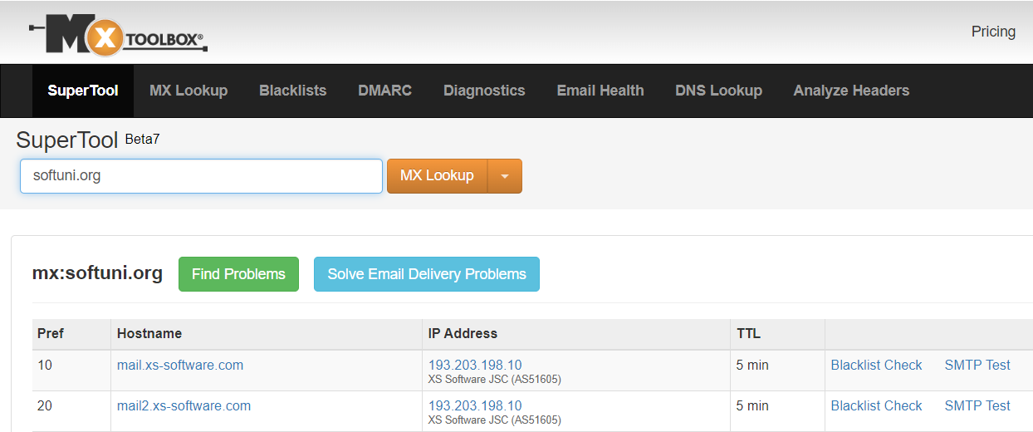

## Play with Dev Tools

**To open Dev Tools in Google Chrome on Windows, press F12 or Ctrl + Shift + I**

**1. Open a REST service with the Web browser**

- Open a REST service URL in the browser e.g., <https://restcountries.com/>. You can read the documentation there or directly navigate to <https://restcountries.com/v2/name/Bulgaria/>

- You can use the web browser's Dev Tools to explore the response headers, request headers, and JSON data returned by the service.

**2. Execute HTTP GET**

-

**3. Execute HTTP POST (fill a login form and submit it and see the requests in the Web browser Dev Tools)**

-

### 3.1. Open a REST service with the Web browser

- Open a REST service URL in the browser e.g., https://restcountries.com/. You can read the documentation there or directly navigate to https://restcountries.com/v2/name/Bulgaria/

- You can use the web browser's Dev Tools to explore the response headers, request headers, and JSON data returned by the service.

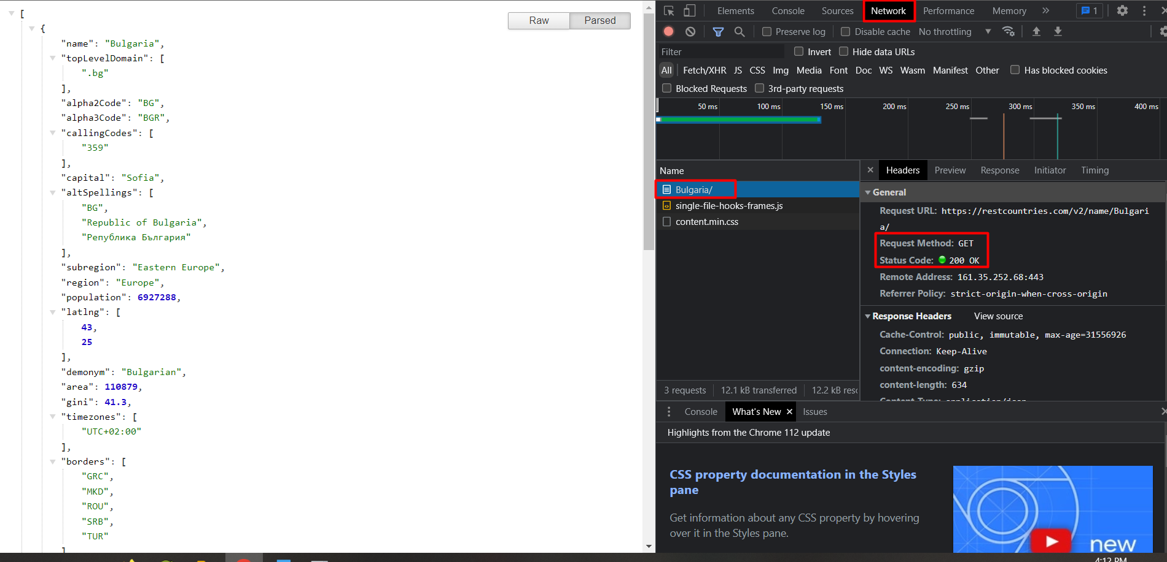



### 3.2. Execute HTTP GET

To execute an HTTP GET request, navigate to

[**https://560e2a43-3843-49f3-a54e-bffa811e403b-00-m0wjrn2057ty.global.replit.dev/**](https://560e2a43-3843-49f3-a54e-bffa811e403b-00-m0wjrn2057ty.global.replit.dev/)

- Open the web browser's Dev Tools, if they're not already open.

- In the Dev Tools, you should see a new HTTP GET request listed in the network panel. Click on it to see the request and response headers, as well as any JSON or HTML data returned by the service.

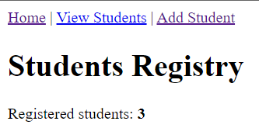

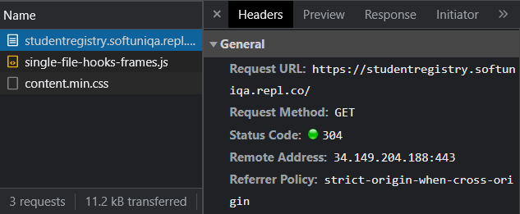

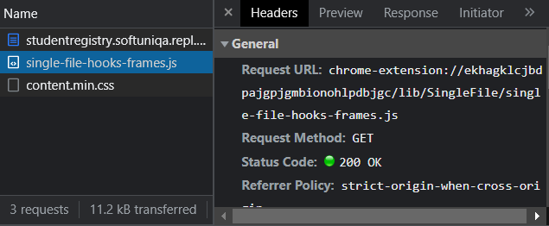

### 3.3. Execute HTTP POST

1. To execute an HTTP POST request, navigate to   
<https://560e2a43-3843-49f3-a54e-bffa811e403b-00-m0wjrn2057ty.global.replit.dev/>



2. Go to "Add Student"

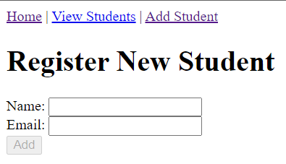

3. Open the web browser's Dev Tools, if they're not already open.

4. In the Dev Tools, go to the "Network" tab.

5. Enter some name and email and **click Add button.**

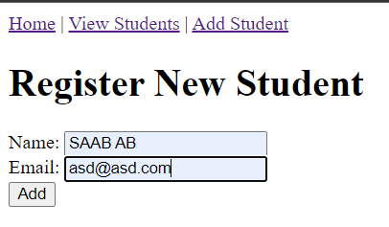

6. In the Dev Tools, you should see a new HTTP GET request listed in the network panel. Click on it to see the request and response headers, as well as any JSON or HTML data returned by the service.

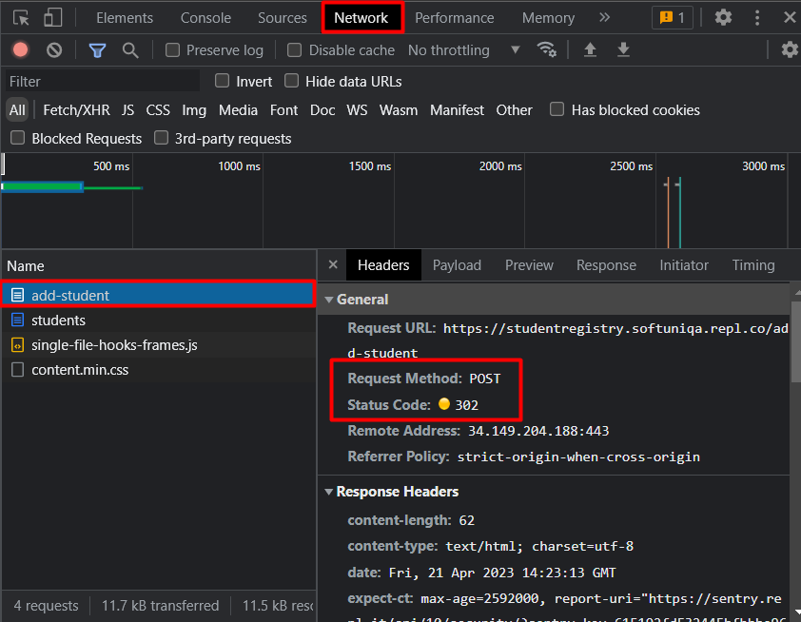

## * Email setup (optional exercise)

### 4.1. Download and install Thunderbird

**1.** Navigate to [**https://www.thunderbird.net/en-US/**](https://www.thunderbird.net/en-US/) and click "FREE DOWNLOAD" button

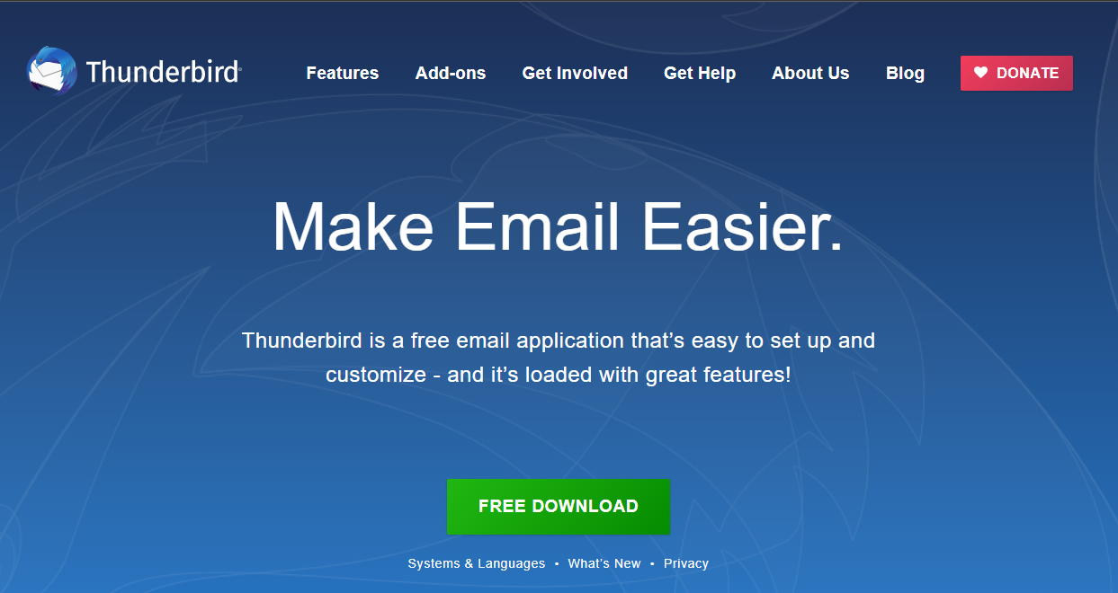

**2.** This will download the Thunderbird Setup.exe. Open it to start the installation. Give permission to make changes.

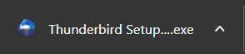

**3.** On the **welcome screen** hit **"Next"** and on the next screen choose **"Standard Setup Type".**

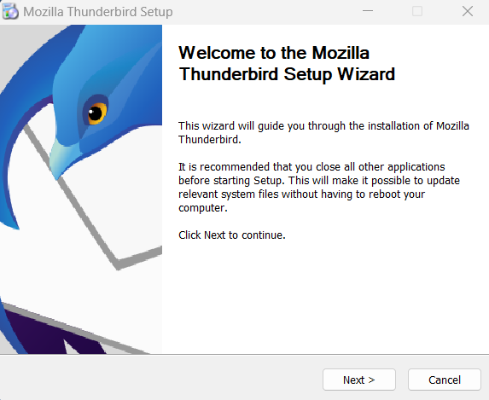 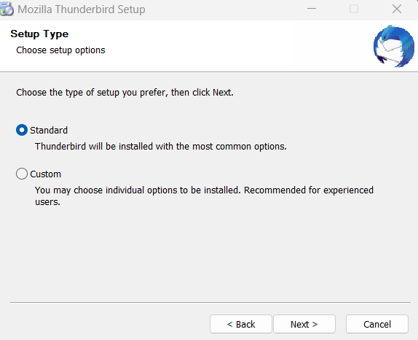

**4.** On the next screen, **decide** if you'd like to use **Thunderbird as your default email application** or not. Hit **"Install".**  
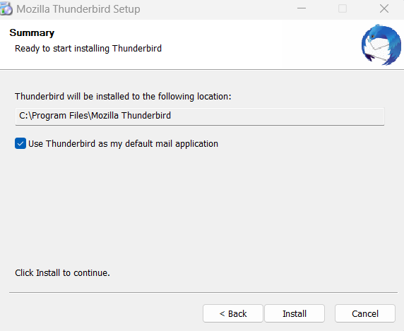

**5. Finish** the installation**.**

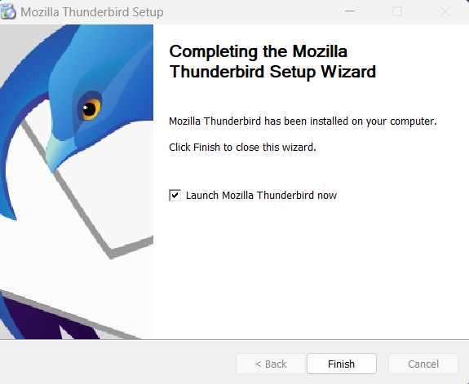

### 4.2. Configure Gmail to work with Thunderbird

1. To **configure Thunderbird to work with Gmail**, first **ensure IMAP is enabled on your Gmail account** (the default for new Gmail accounts).

- On your computer, **open Gmail**.

- In the top right, click **Settings** and then **See all settings**.

- Click the **Forwarding and POP/IMAP tab**.

- In the "**IMAP access**" section, select **Enable IMAP**.

- Click **Save Changes**.

2. Open Thunderbird. Fill your names, existing gmail account and its password. Then click "Continue".

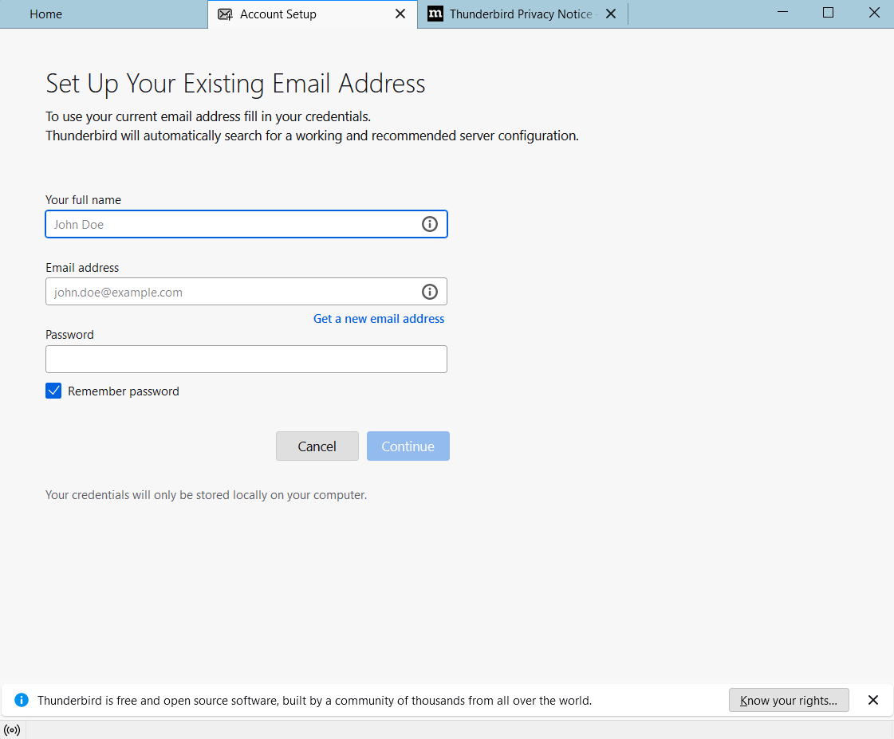

3. If successful you will get the following message. Click **"Done"** and you're ready to go. Or you can configure it manually.

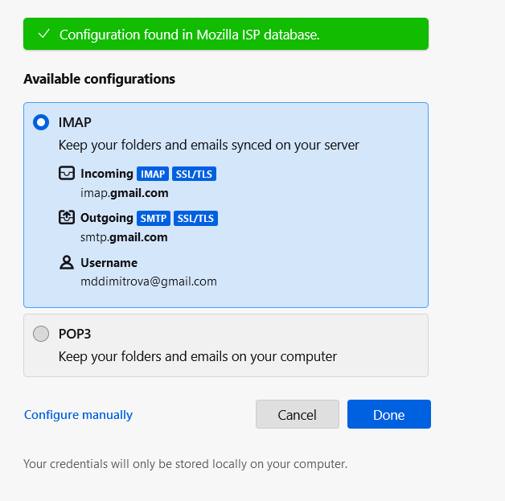

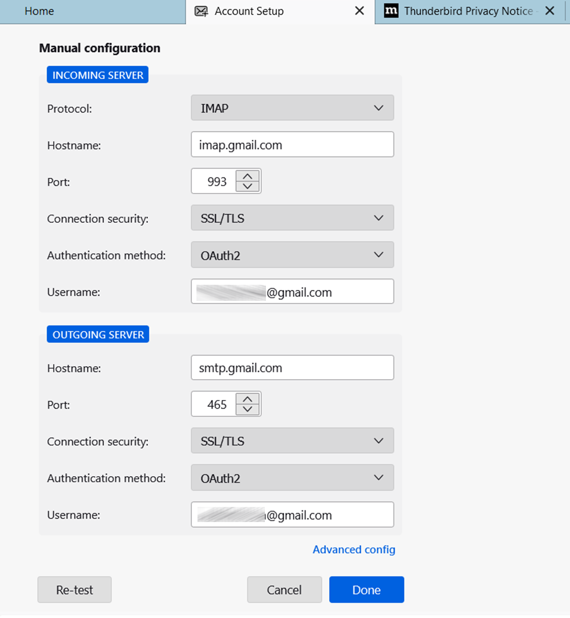

**4.** Next you will have to **authorize Thunderbird** to access your google account. Maybe you will have to confirm that it is you via your mobile phone.  
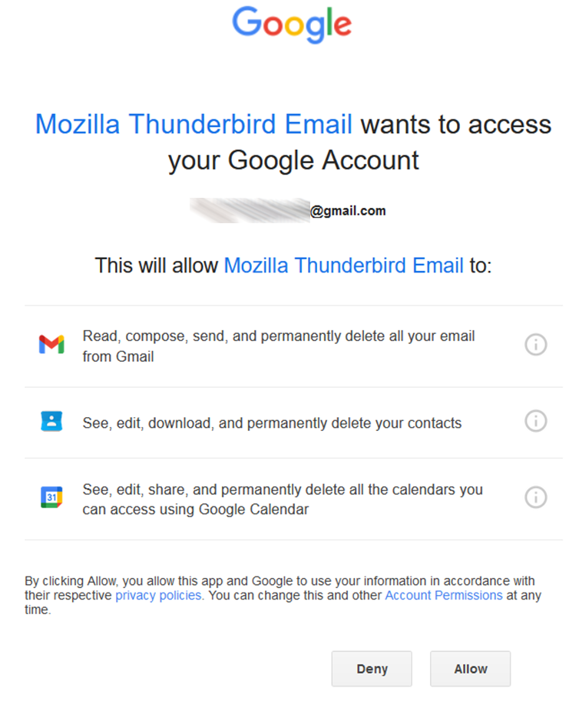

**5. Thunderbird is now ready to use** and will automatically download your messages in its Inbox.

